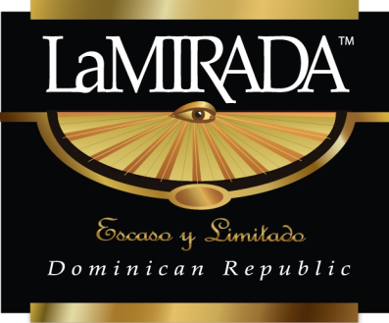
Press Release – LaMirada Premium Cigars
Jpeg photo-file attached.
Contact: | John Geoghegan | Roy MacLaren
 | Marketing Director | President & CEO
 | Bahama Mamas LLC | Bahama Mamas LLC
 | 310-809-7988 (mobile) | 224-226-2913 (mobile)
 | 866-316-1991 | 1-866-316-1991
 | Johngeo3646@gmail.com | roy@bmcllc.us

LaMirada Cigars Are Created for the 2020 Humidor
Classic elegance and 13-year-old Connecticut wrapper make LaMirada a must.
November 23, 2019 – Charlotte, NC; Bahama Mamas, LLC is pleased to announce the issue of LaMirada limited edition premium cigars. Made in the Dominican Republic, LaMirada is the result of a joint effort between Bahama Mamas and Tabacalera Palma to relaunch these exquisite cigars in 4 classic sizes. Using 13-year aged true Connecticut shade wrapper and a complex blend of 3 filler tobaccos, LaMirada achieves a classic balance of body and smoothness in an elegant, contemporary new package.
“LaMirada represents the culmination of our work together, not only to deliver a timeless line of cigars, but also an updated brand cache that premium cigar smokers can make their own,” remarked Roy MacLaren, LaMirada’s CEO. LaMirada in Spanish is ‘a glance” or “a look” or “the view”, depending on how it’s used in conversation. It can feel worldly or intimate to match the cigar occasion.
“When we bought the Bahama Mamas company, we set our sights on bringing its larger cigars up to today’s premium standards at a value price point,” MacLaren continued. “We did that. Now we’re moving further along with a rebranding of a classic. We can now deliver 2 premium brands with unique differences at 2 price points for the tobacconist.” LaMirada cigars will be available to premium tobacconists in four sizes, beginning January 2020.

About Bahama Mamas, LLC
Bahama Mamas LLC was founded in 2016 following the purchase of the Bahama Mamas cigar brand. The company is now based in Charlotte NC with sales and distribution in major U.S. markets. Beginning in January 2020, the company will have 2 distinctive brands of premium imported cigars for licensed distributors and retail tobacco shops. LaMirada cigars are being introduced in January 2020 to be an upscale companion brand to Bahama Mamas, offering an exquisitely rich and complex cigar experience using 13-year aged Connecticut Shade Wrapper and 3 different filler tobaccos. Bahama Mamas Cigars are the branded successor to Havana Honeys’ larger sizes, flavors, and blends. The cigars were introduced in 1997 and rebranded in 2009 in a range of natural leaf imported sizes. The company has maintained its premium portfolio, and has upgraded the Dominican handmade quality. The company has also updated the marketing and product strategy to reduce flavor levels below the characterizing premium tobacco tastes and aromas in anticipation of future FDA rules. The company’s ongoing mission is to bring cigar smokers affordable handmade cigars with premium tobacco in sizes that fit any occasion. Information on both brands is available by calling 1-866-316-1991 or visiting www.BahamaMamasCigar.com

