****TM

**Press Release - Bahama Mamas Cigars**

*Jpeg photo-file attached.*

|  |  |  |
| --- | --- | --- |
| **Contact:** | **John Geoghegan** | **Roy MacLaren** |
|  | Marketing Director | President & CEO |
|  | Bahama Mamas LLC | Bahama Mamas LLC |
|  | 310-809-7988 (mobile) | 224-226-2913 |
|  | 702-418-3700 |  |
|  | Johngeo3646@gmail.com | roy@bmcllc.us |

**NEW Petite Corona 4-Packs from Bahama Mamas.**

*Four styles ready to go anywhere. Five pack counter unit for real business.*

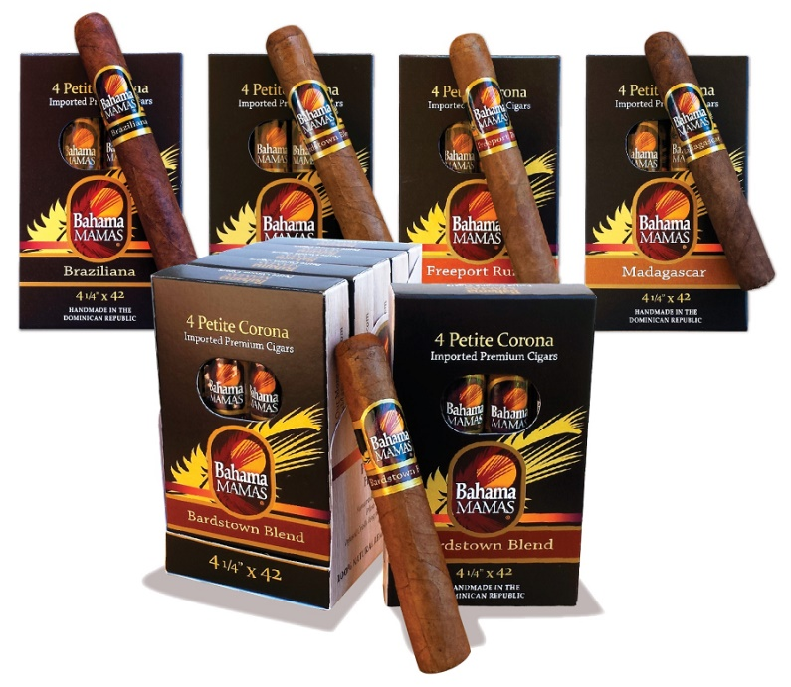­**October 1, 2019 – Charlotte, NC;** Bahama Mamas LLC has announced that its handmade Petite Corona premium cigars will now be available in convenient 4-packs. The new 4-packs will be delivered in a compact 5-unit counter display to extend the presence of Bahama Mamas Petite Coronas 20-cigar box outside the Smokeshop humidor.

“We’re excited about the new packs. It’s another way to offer cigar smokers an affordable premium experience with great balanced and unique taste accents with a little island style mixed in”, says Bahama Mamas President Roy MacLaren.

The new 4-packs are the next step delivering Bahama Mamas upgraded quality to U. S. adult premium cigar smokers.

More information is available by calling 866-316-1991 or visiting www.BahamaMamasCigar.com.

-----

**About Bahama Mamas Cigars**

*Bahama Mamas Cigars are the branded successor to Havana Honeys’ original sizes, flavors, and blends. The company has maintained the portfolio in historically popular sizes and flavors, and has retained its smooth balanced blends and Dominican handmade quality. Now headquartered in Charlotte, NC, the cigars were introduced in 1997 and rebranded in 2009 in a range of natural leaf imported sizes. The cigars have traditionally been offered in an infused range of adult flavors. Today they are accents, rather than characterizing the taste of these premium handmade imported cigars. Bahama Mamas ongoing mission is to offer cigar smokers an affordable cigar with premium tobacco and smooth, balanced enjoyment in sizes that fit any occasion. The brand is focused on delivering the Bahama Mamas experience to U. S. adult cigar smokers via smoke shops, tobacco specialty outlets as well as on the Internet. Information is available from Bahama Mamas by calling 1-866-316-1991, or visiting www.BahamaMamasCigar.com*